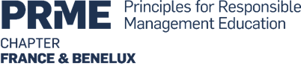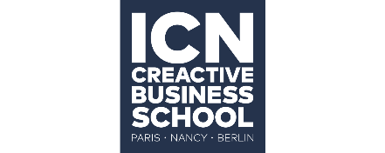

Education and Research with Purpose: Connecting Nature and Knowledge for Sustainable Leadership

PRME France-BeNeLux 2026 Conference May 21-22, Nancy, France

CALL FOR IMPACTFUL SUSTAINABLITY/RESPONSIBLE MANAGEMENT PROJECTS

Share a sustainability project of which you are particularly proud
Submit a proposal to present your own or your university's/school’s sustainability project(s)/initiative(s)/idea(s).

Proposals are in the areas of responsible management/sustainability education, research, campus operations, and community outreach, or transversal and preferably centred, but not only, on this year’s theme: Connecting Nature and Knowledge for Sustainable Leadership.

Key dates
4 February 2026
o Launch of calls for impactful sustainability project proposals
o Opening of event registrations with early bird rate
24 April 2026
o Last day to benefit from early bird registration rates
30 April 2026
o Last day for sending submissions for impactful sustainability projects
5 May 2026
o Final confirmations sent for acceptance of submissions for impactful sustainability
projects
7 May 2026
o Closing of registrations and payments
18 May 2026
o Final version of conference programme posted online

B) Impactful Sustainability/Responsible Management Project Submission form
Last name
First name
Job Title
Institution
Email
Phone including country code
Project title
Project theme (possibility to choose one or more of the themes below)
- Impact & Engagement
  - How do students create impactful initiatives?
  - How do educators encourage impactful initiatives?
- AI for Good
  - How do students use AI for good?
  - How do educators use AI for good?
- Inclusive education and neurodiversity
  - How to deal with learners’ hidden differences?
  - How do we teach with empathy?
- Engagement & Progress Reporting
Discuss best SIP practices, the dos and don’ts, and the most efficient ways to showcase your achievements and progress.
- Dissemination, Sharing & Cooperating
How to organise your research when working with partners, crossing the boundaries of your discipline or experimenting with new techniques?
- Academics, influence, Impact for Society
Making Research Matter to the Public: Roles of influencers: Scholars, journalists, networks, and PR Teams

Project Description (1 page)
Make a separate submission for each Impactful Sustainability Project you propose.
Give your project a title.
Indicate:
i) theme(s) you believe you can make a meaningful contribution to;
ii) aim of your project;
iii) target public;
iv) how you wish to deliver your presentation at our conference;
v) how you integrate the i5 approach with success, and what areas you want to work further on;
vii) critical assessment of your experience in implementing your project.
Send your proposal to: confererence.prme.2026@icn-artem.com. We’ll get back to you asap with the evaluator’s feedback. In the meantime, we advise you to proceed to registration for the conference and pay upon acceptance of your proposal.
https://www.icn-artem.com/en/event/prme-chapter-france-benelux/

Start writing here

